Sethatevy Bong

Project 3

Pseudocode for the program:

1. Print welcome menu of the hotel

2. initialize the values for four different rooms

3. prompt and read the location where this hotel chain is located and the number of floors in the hotel (the total number of rooms on each floor may not exceed 30, continuously ask for the correct number of rooms within the range of 1 and 30)

4. Prompt and read the number of occupied rooms for each room type on this floor (the total number of rooms on each floor may not exceed 30, continuously ask for the correct number of rooms within the range of 1 and 30)

5. check that the total number of occupied rooms on each floor does not exceed the total of rooms on that floor

6. print the rates of room types and calculate hotel income based on the room type and its rate

7. calculate the total number of rooms, total number of occupied and unoccupied rooms, and rate of occupancy.

8. print the results and find the Floor number with the minimum number of rooms (if the occupancy rate is less than 60%, then print a message)

9.Print programmer's and project's information

Output screenshot

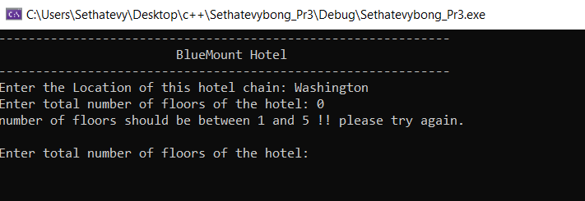

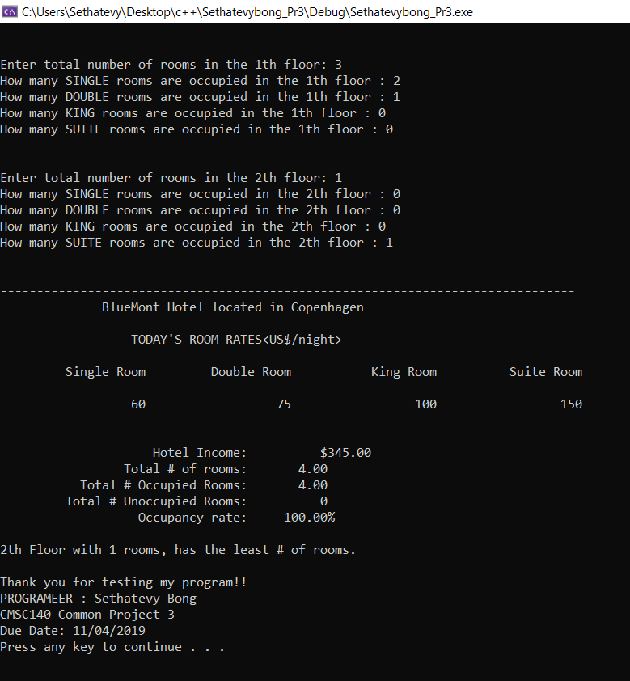

**Lesson Learned**

I think this is by far the hardest programming project I have encountered. At first, I tried to use different loops because I was not sure which one should I use. After receiving help from the Ackerman learning center, I more familiar with the how to loops work in the program. In sum, the construction of loops and recurring calculation, took me so a long time to correct my program, but this also allows me to remember what I did wrong.

This project really helps me becoming more familiarize with chapter 5. I also notice that I still need further revision for chapter 5. After I received helps from the Ackerman Learning Center, now I know the mistake that I made. I think going to the computer programming lab is really helpful. In the future, I plan to spend more time over there and do my programming studies.

Test Plan

|  |  |  |
| --- | --- | --- |
| Data Item | Test Case #1 Values | Test Cast #2 Values |
| Location | Washington | Copenhagen |
| # of floors | 0 | 2 |
| Input value |  | 1st floor : in total 3 rooms - 2 single room and 1 double room  2nd floor : in total 1 room – a suite |
| Expected Output | Number of floors should be between 0 and 5 !! Please try again! | -Hotel income = $ 345.00  -total number of rooms = 4  -Total number of occupied rooms = 4  -Total number of unoccupied rooms = 0  -Occupancy Rate = 100. 00%  -2nd floor with one room, has the least # of rooms |
| Did the test pass? | Yes | Yes |
| Actual Output | Number of floors should be between 0 and 5 !! Please try again! | -Hotel income = $ 345.00  -total number of rooms = 4  -Total number of occupied rooms = 4  -Total number of unoccupied rooms = 0  -Occupancy Rate = 100. 00%  -2nd floor with one room, has the least # of rooms |